North Lincolnshire Council
Daily Event Analysis
3rd November 2010

Overview
The Dawes Lane Coke Oven Osiris (DLCO) measured a daily mean PM₁₀ concentration of 55µg/m³ on Wednesday 3rd November 2010 exceeding the allowed 50µg/m³ as a daily mean. The Low Santon TEOM measured a daily PM₁₀ concentration of 37μg/m³. A check of the data has revealed that the PM₁₀ concentrations were significantly above the 50μg/m³ threshold between 00:00 and 08:00 at the DLCO Osiris, the same period at the Low Santon TEOM measured concentrations consistently below the daily objective limit. The average PM₁₀ concentration for this time period at the DLCO Osiris was 80μg/m³. The Low Santon TEOM averaged at 26μg/m³.

Met Conditions
Consistent SW winds were recorded throughout the day. The wind within the 8 hour period of focus ranged between 249° and 269°. Wind speeds averaged at 3.2 m/s. Heavy rain was observed in the afternoon around 15:00.

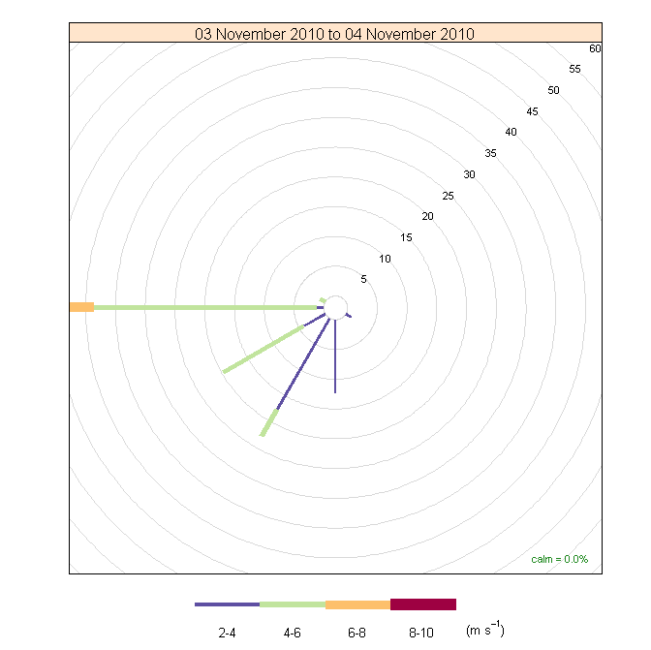

Episode Wind Range

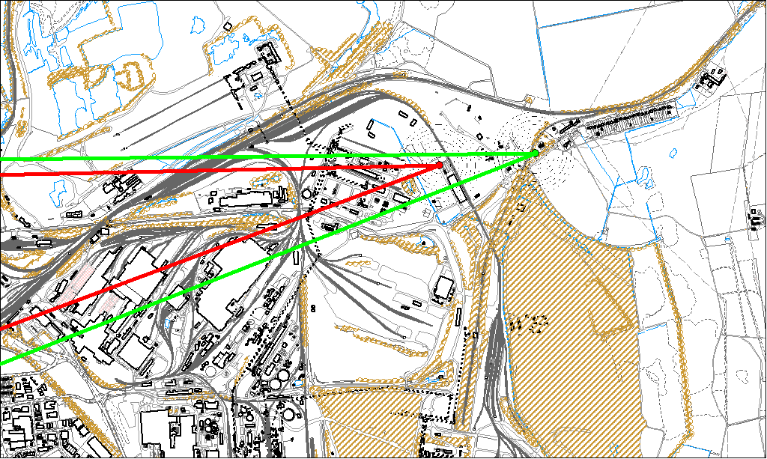

Potential Sources
The above map shows the DLCO Osiris (indicated by the red lines) and the Low Santon TEOM (indicated by the green). The highest concentration recorded during the 8 hour period of focus at the DLCO Osiris matched the most Westerly wind direction.

As the Low Santon TEOM measured consistently lower concentrations during this period, it is likely that the DLCO Osiris was affected by a localised source most probably a 24hr operation due to the times of the highest concentrations. The closest source to the Osiris is the Dawes Lane Coke Ovens.

The likely areas include;

- Dawes Lane Coke Ovens
- Part B Activities, Dawes Lane

